**QR CODE BASED HALL TICKET SYSTEM FOR STUDENTS**

**ABSTRACT**

The project entitled as **“QR Code Based Hall ticket System for Students”** has developed using JAVA as front end and My SQL server as back end. This project is being created to decrease the effort of human and forgery in hall tickets in the educational institutes. The hall ticket is fully based on the Quick Response (QR) code, which is a new embedding technique. This project is the pure automated solution and it will help to generate student hall ticket easily. It is a special type of software which will be used to make a secure hall ticket with QR code instead of the bar code

In current scenario, educational institutes have different types of examinations. For all these they need to distribute hall ticket. In the existing system, there are printed hall tickets are used. So any one can forge and make malpractice over the printed copies. The main aim of this project to generate unique QR code for students’ hall tickets. This helps to keep the data secret. Using the QR reader/scanner the hall ticket information’s can be extracted. Using this application, the admin can generate hall ticket for individual students; this will be transferred via email.

The students can take printout of these QR codes at the time of examination. In this automated system the hall ticket and results data generation process is completely done by the computer with the help of the software.

**SYSTEM SPECIFICATION**

**HARDWARE SPECFICATION**

* Processor : P 4 700 GHz.
* RAM : 4 GB RAM
* Hard Disk Drive : 180 GB

**SOFTWARE SPECIFICATION**

* Operating System : Windows 7/8/10
* Front End : JAVA
* Back End : SQL

**MODULES**

**Teacher/Admin Login**

Admin/Teacher either can using this application to follow the bellow the modules. This user entering the username and password to login into the application. We have admin table having some fields in the table like, name, age, gender, username, password etc…

**Student Registration**

This module has been handling by the admin, this module collects the all the information about the student. Once all the fields values have collected then can register it. These values have been stored in to the student table.

**Hall Ticket Registration**

After the student registration have been completed, the admin registered the hall ticket details. This record will be stored in to the hall ticket table. Once the ticket has been registered then the QR code has been generated.

**QR Code Generation**

QR Code will be generated and viewed into the server, when student login into the application it will can shown into the hall ticket details screen.

**Student Login**

Once the student registration has been completed, then they have unique username and password. Which fields are collect the information from the student table. If the username or password is incorrect, we won’t allow to enter into the application.

**View Hall Ticket**

Student can able to view the hall ticket as a QR code. When student reached the exam hall the teachers scanning the QR code view the student details accordingly.

**Data Flow Diagram / USE Case Diagram**

**LEVEL 0**

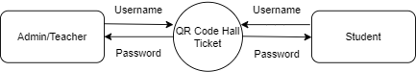

**Level 1**

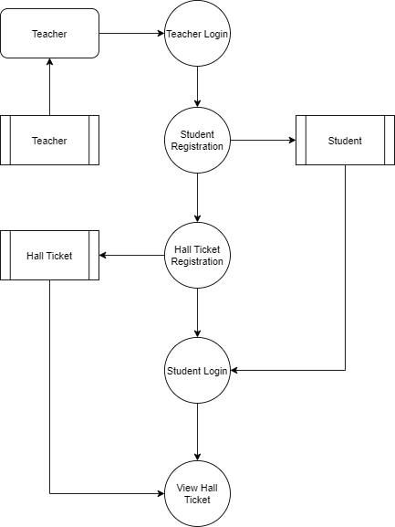

**ER Diagram**

